­­­ 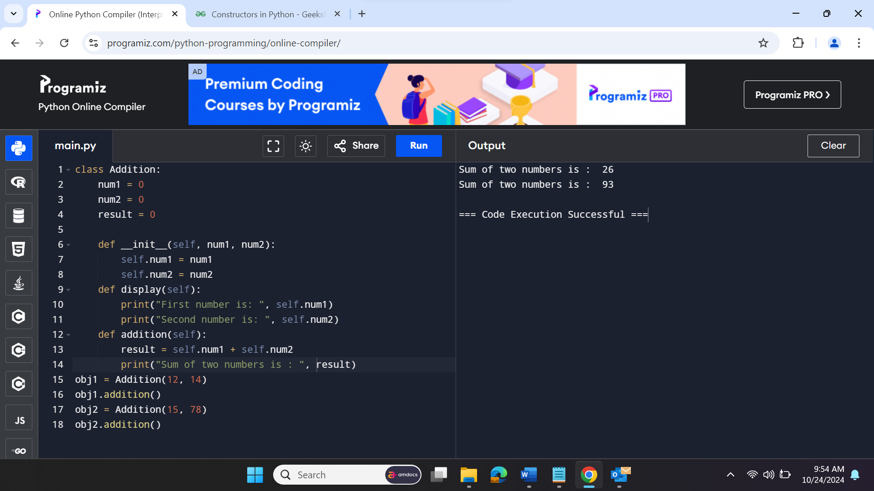

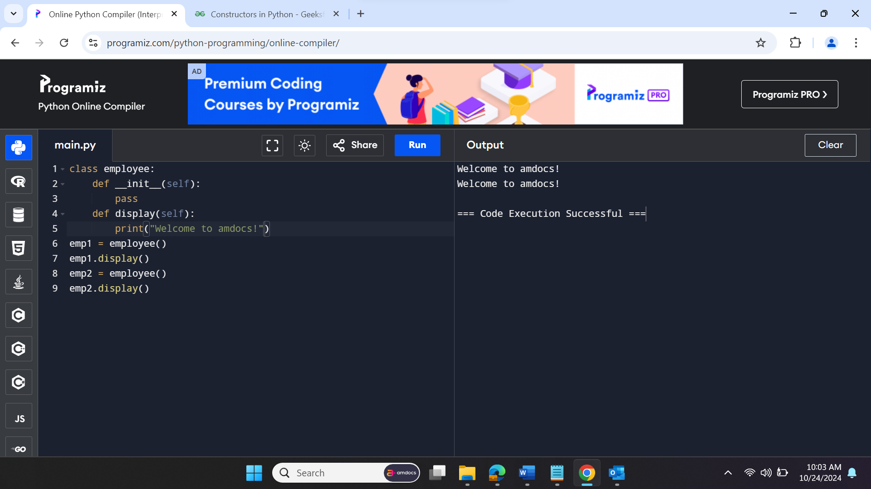

**Single Inheritance**

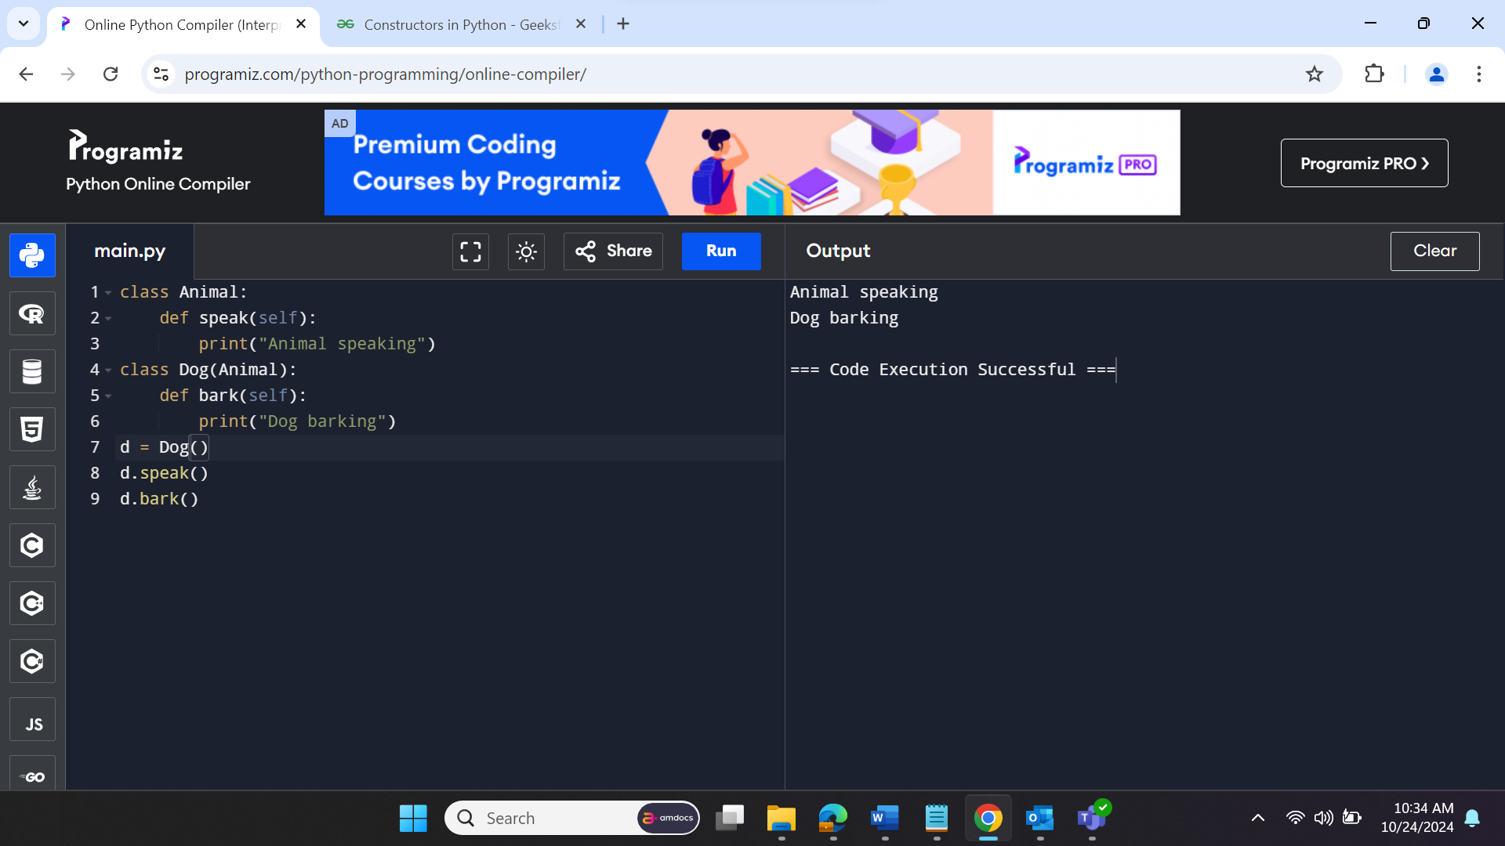

**Multi Level Inheritance**

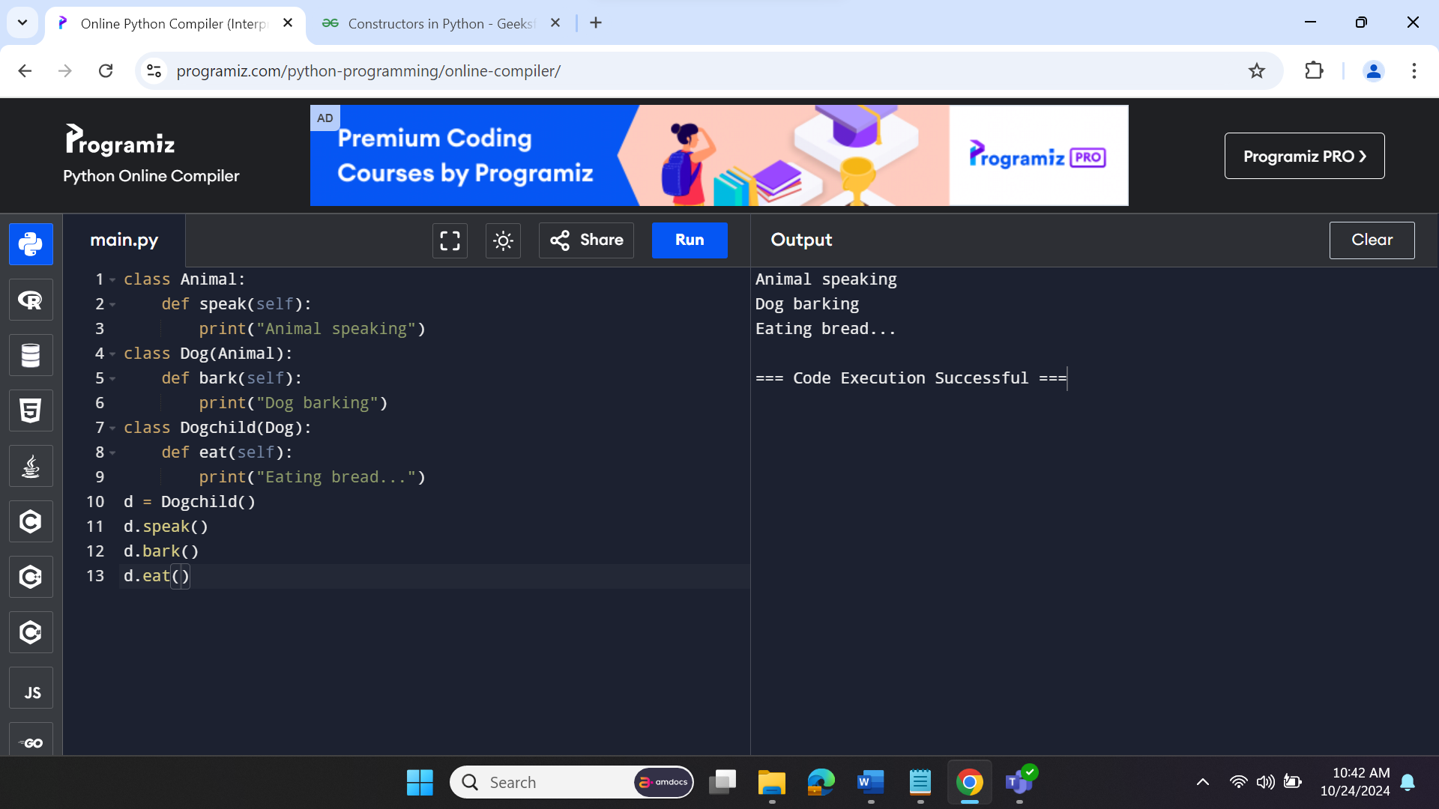

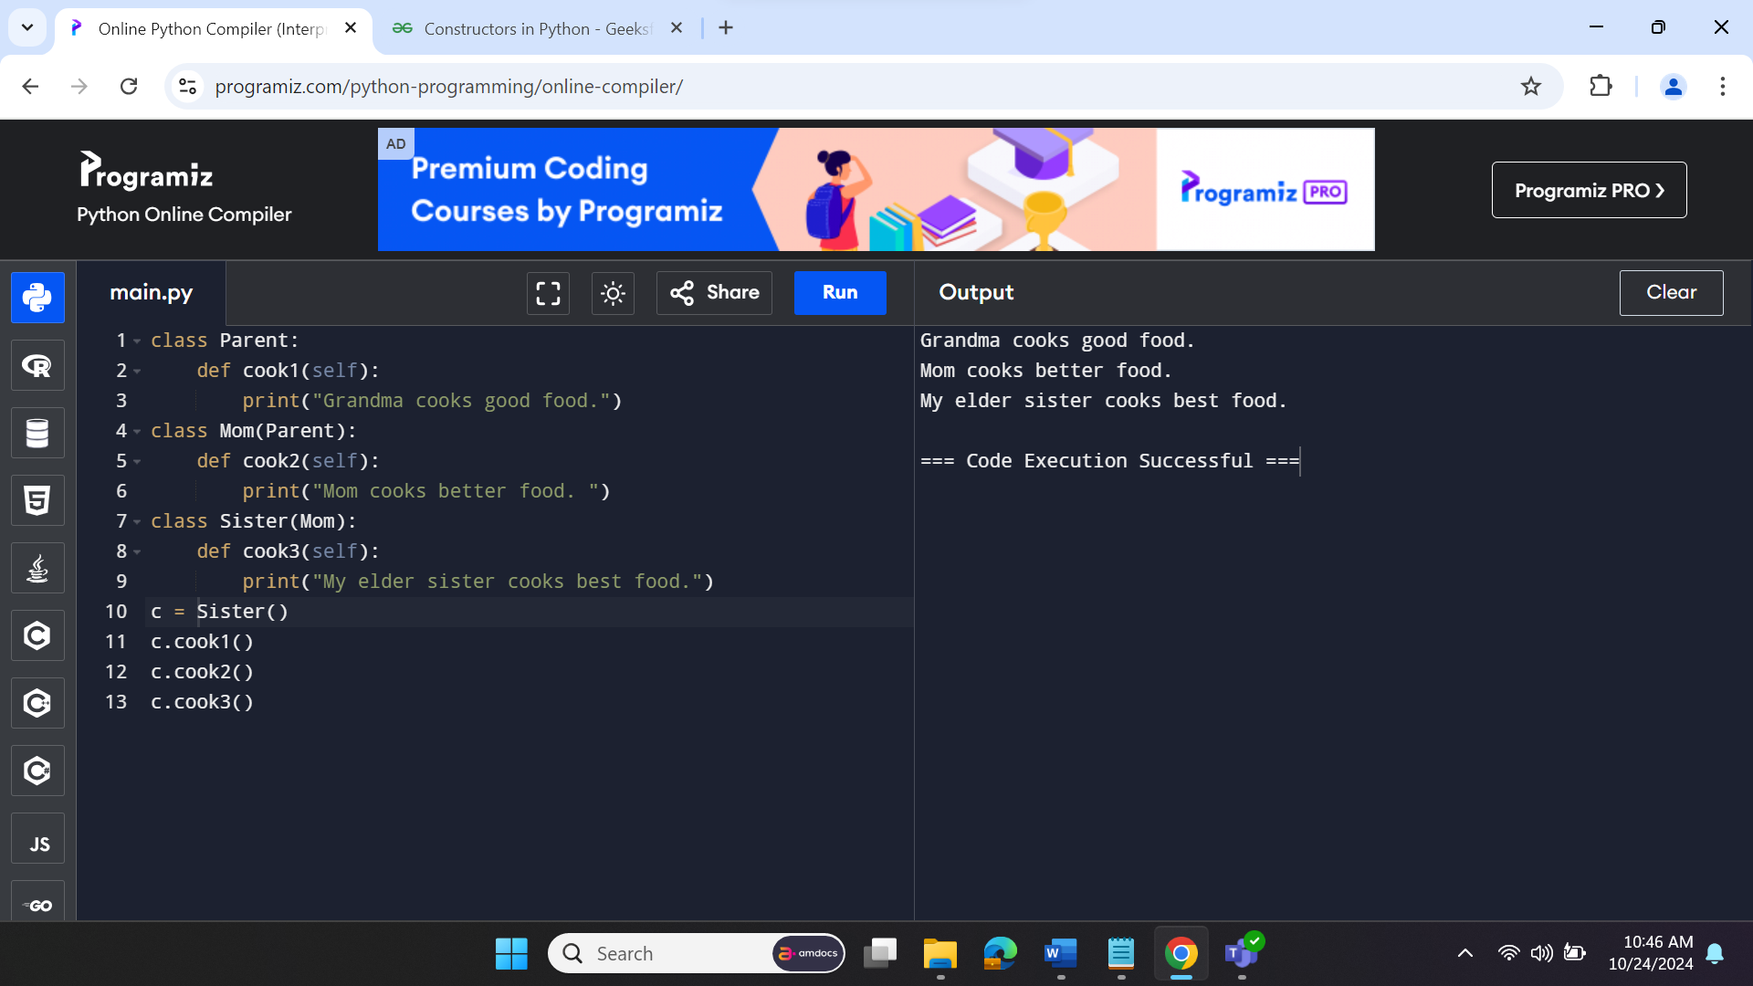

**Multiple Inheritance**

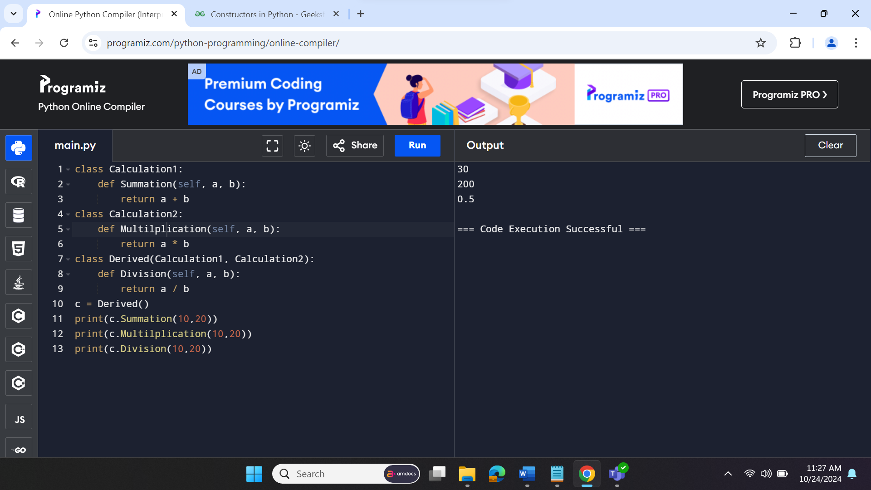

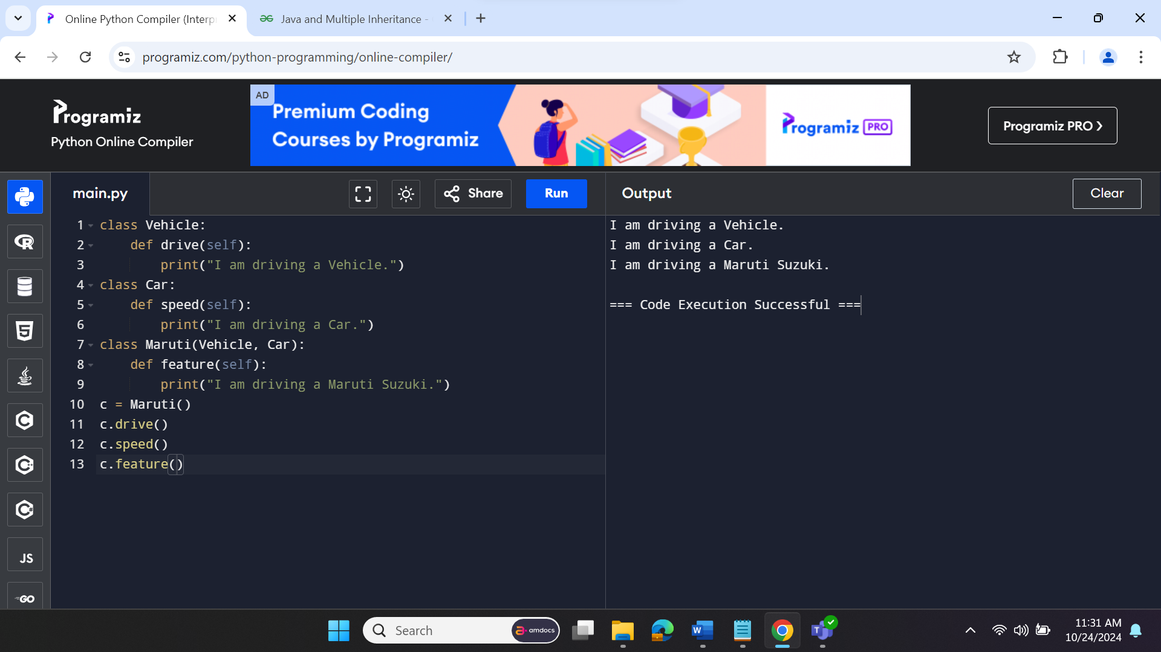

**To check if the sub class belongs to parent class or not**

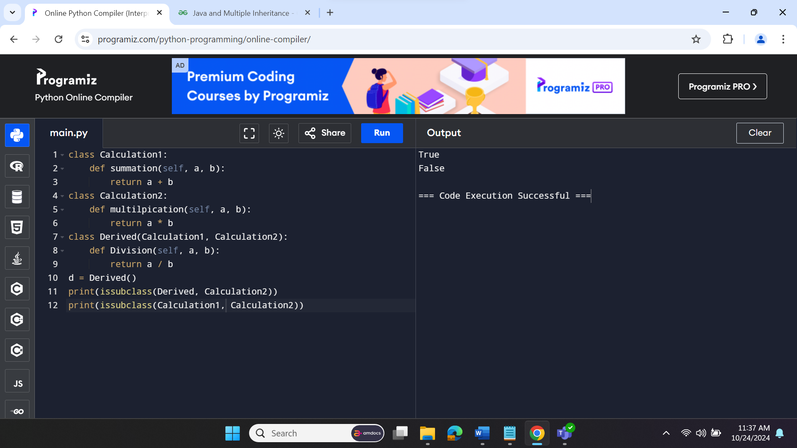

**To check if the instance belongs to respective class or not**

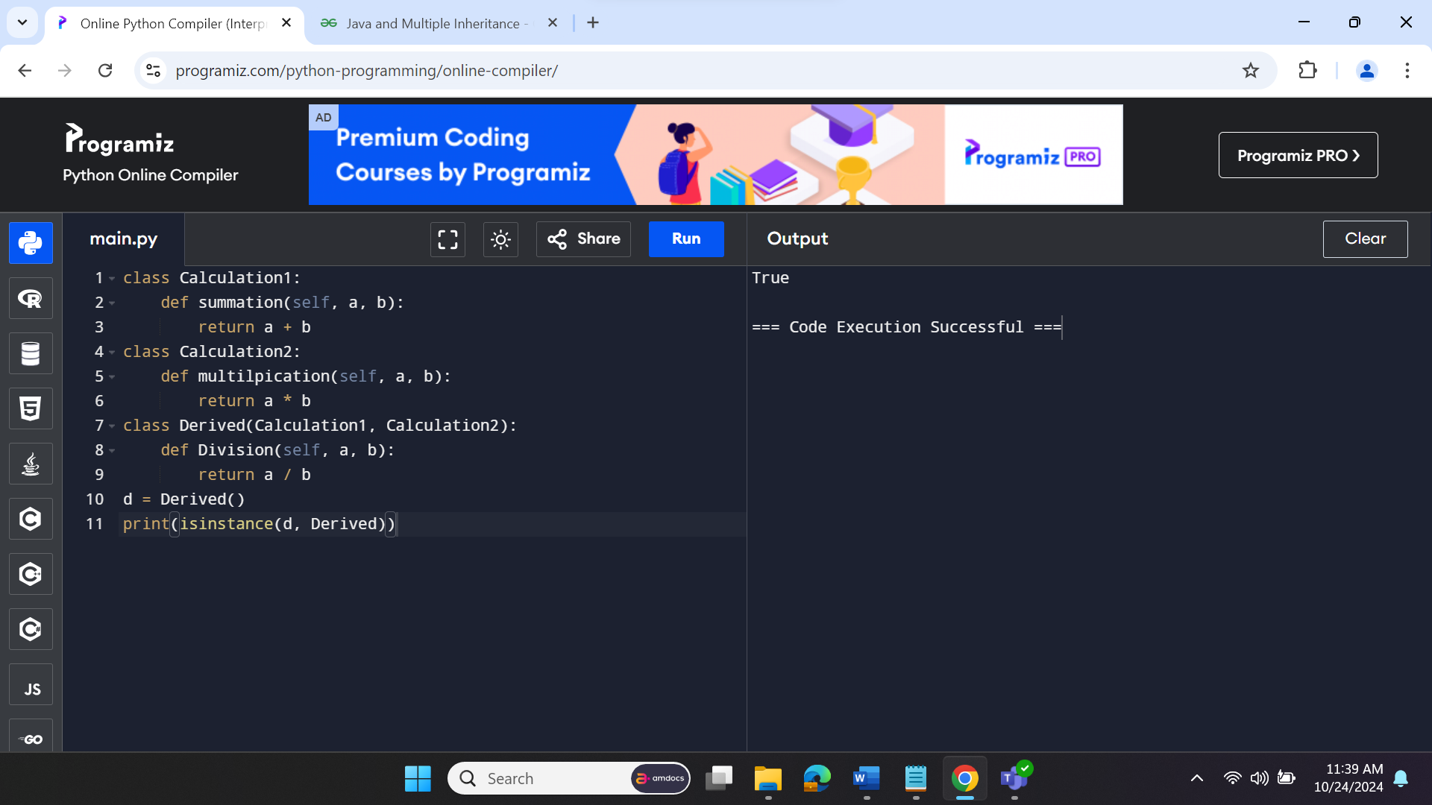

**Method Overriding**

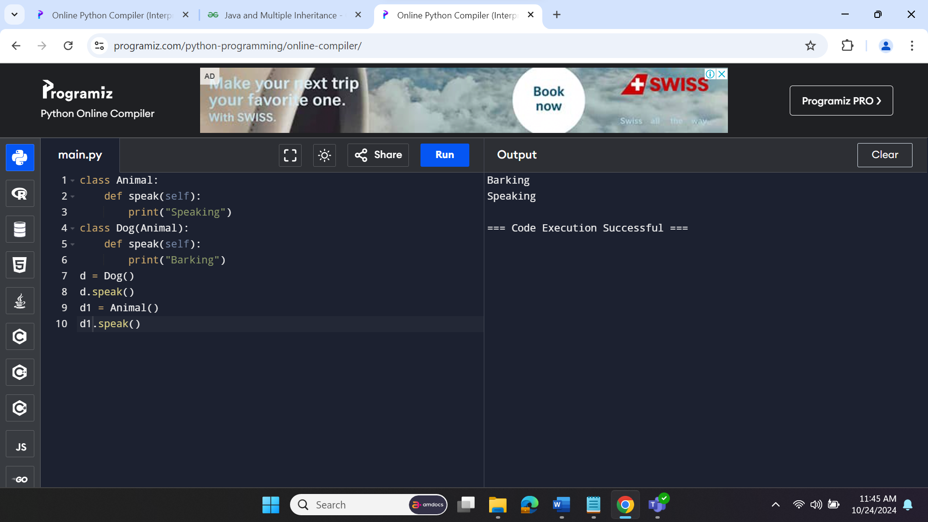

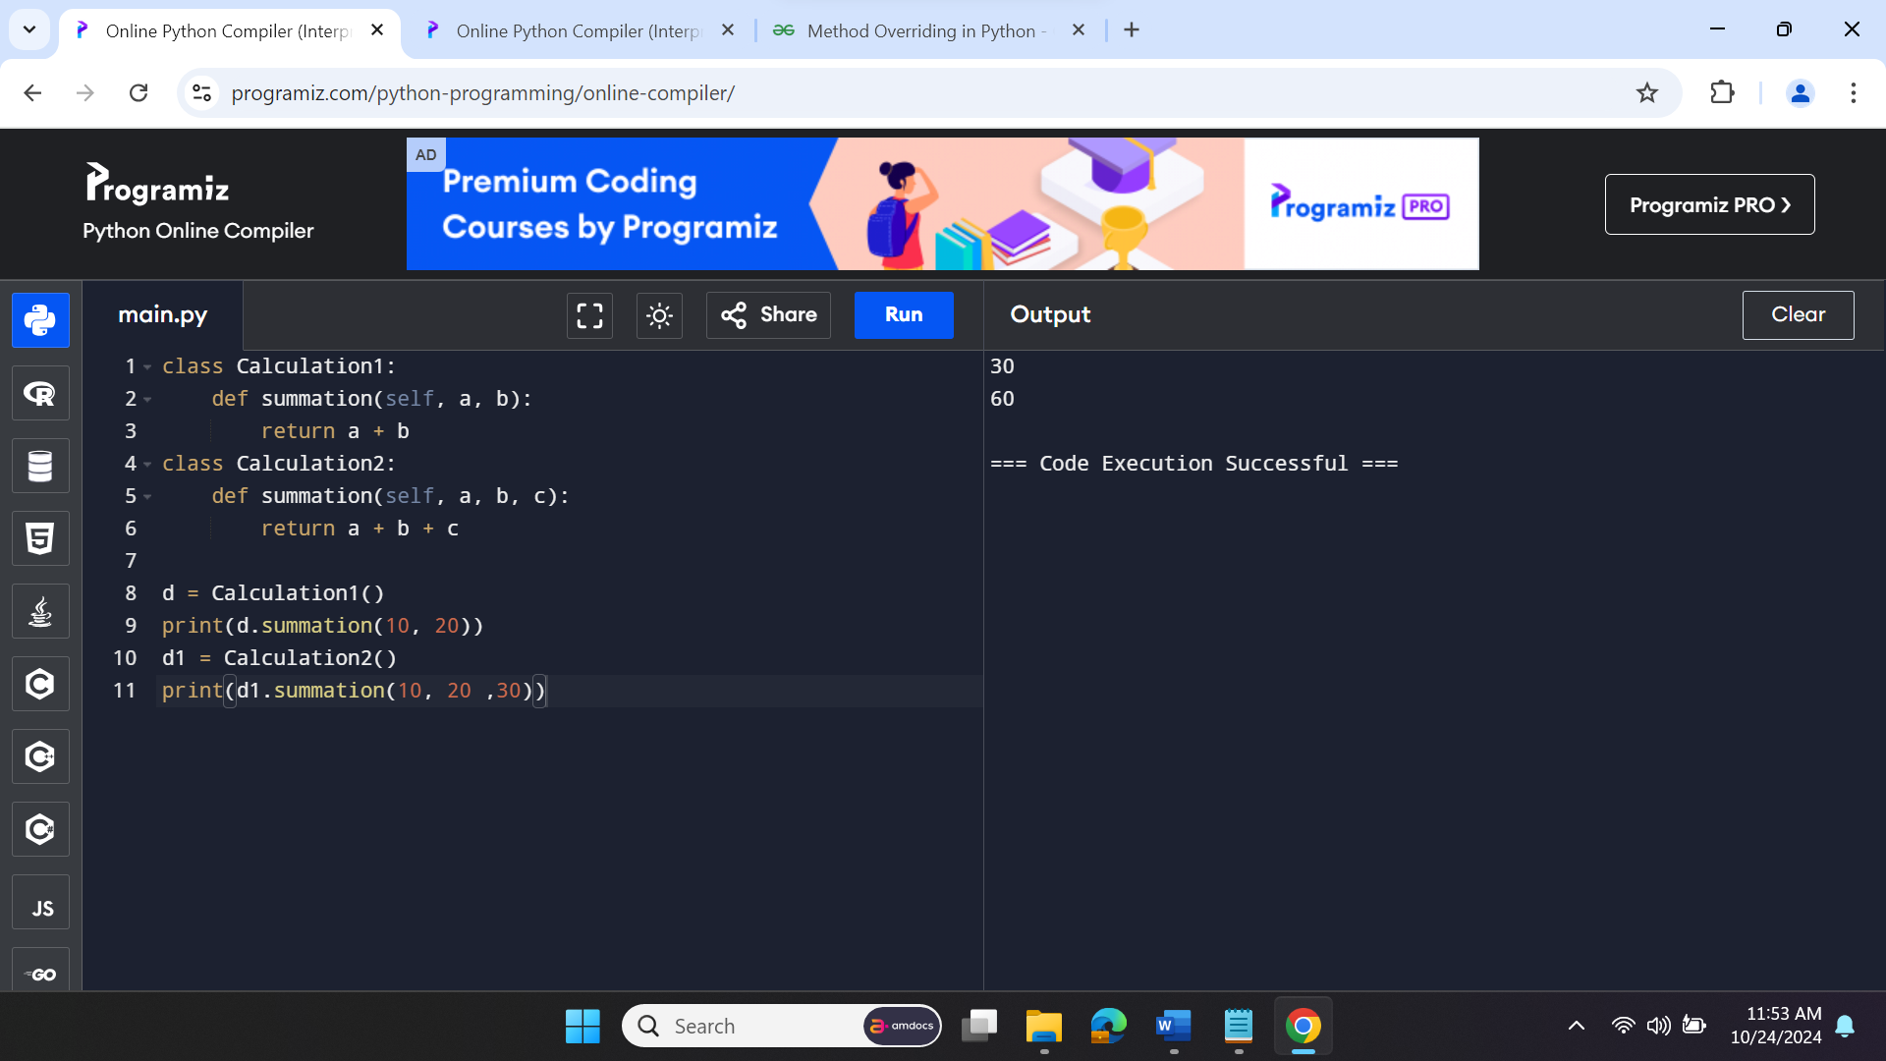

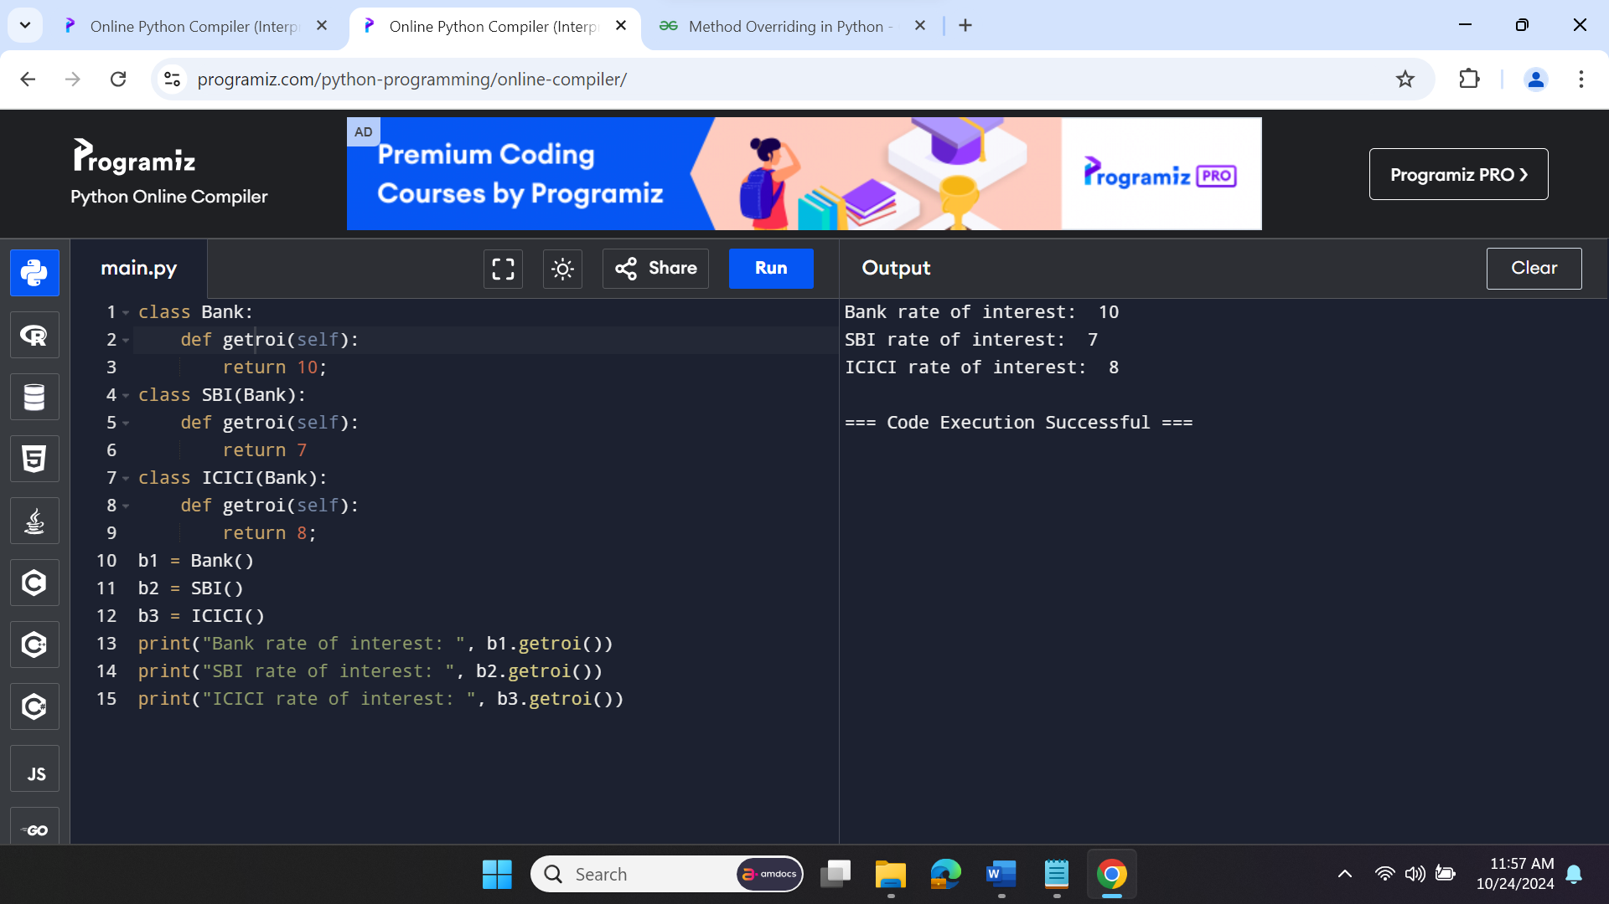

**Method Overriding in Python**

Method overriding is an ability of any object-oriented programming language that allows a subclass or child class to provide a specific implementation of a method that is already provided by one of its super-classes or parent classes. When a method in a subclass has the same name, the same parameters or signature, and same return type(or sub-type) as a method in its super-class, then the method in the subclass is said to **override** the method in the super-class.

**What is Abtraction and its real life example?**

Data abstraction in Python is a programming concept that hides complex implementation details while exposing only essential information and functionalities to users. In Python, we can achieve data abstraction by using abstract classes and abstract classes can be created using abc (abstract base class) module and abstractmethod of abc module.

**Abstraction in Real Life**

Your car is a great example of abstraction. You can start a car by turning the key or pressing the start button. You don't need to know how the engine is getting started, what all components your car has. The car internal implementation and complex logic is completely hidden from the user.

## **Abstraction classes in Python**

Abstract class is a class in which one or more abstract methods are defined. When a method is declared inside the class without its implementation is known as abstract method.

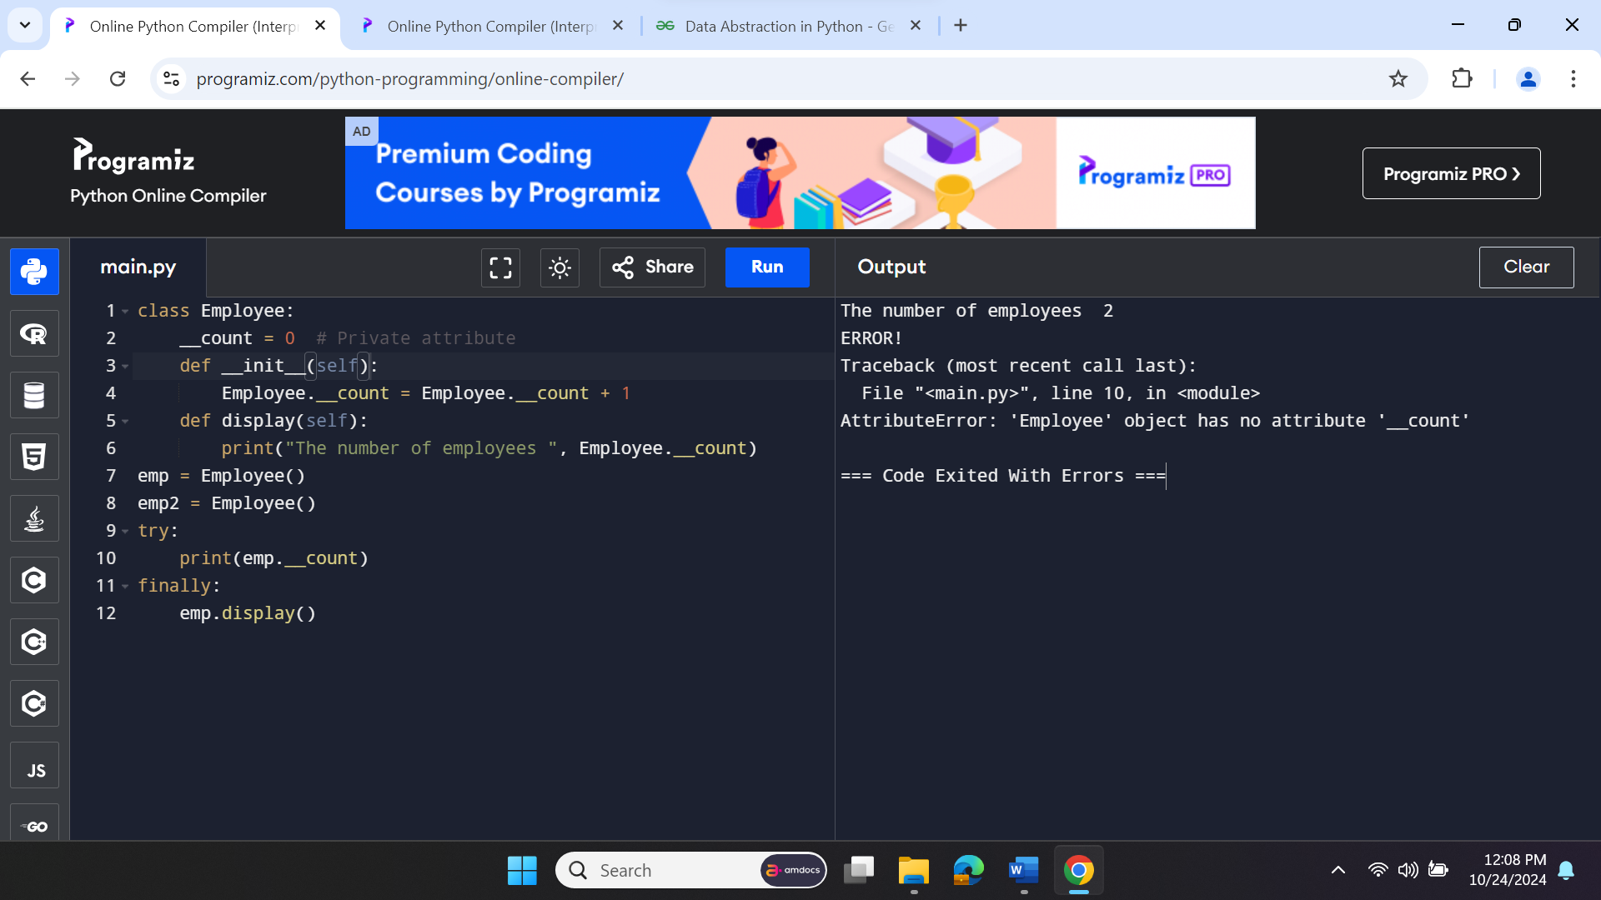

**Polymorphism**

